DAEN 500- DL1 – Data Analytics Fundamentals

Fall 2020 Final Examination Exercise

11/24 – 12/05/2020

Final Submission Deadline: NLT 11:59PM (EST). Saturday, Dec 5, 2010

*Failure to submit ON TIME will result in DAEN COURSE FAILURE*

Name: Steven U GMU G#0

This exam is **OPEN BOOK/OPEN NOTES**. You may consult any of the course texts, and the various reference materials recommended in the syllabus. ***The exam of course IS NOT “Open Web”,*** especially in that you may NOT utilize expert “help” sites such as Stack Overflow, or other programming help or collaboration sites.

HONOR CODE CERTIFICATION

**Your signature above declares that you have followed the conditions of this exam, and that the work is yours alone**. **Specifically:**

This must be your own work, authored and completed by you. As stated earlier, this is an “open source exam” – allowing books, notes or courseware, as well as *general* expert advice gained PRIOR to exam. YOU MAY NOT, HOWEVER, SEED OR USE ANY ADVICE ON HOW TO SOLVE THE QUESTION OR ANY CODE WRITTEN BY ANY OTHER INDIVIDUAL. *Any violation will result in an immediate failure in the exam and for the course, as well as referral to the GMU Honor Committee for determination of any other appropriate disciplinary consequences.*

*NOTE: Your* ***submission*** *of any responses, files, programs, etc. in response to the DAEN500 final exam instructions, will also be your personal certification of your full compliance with the spirit and letter of the* ***GMU Honor Code*** *standards for take home and/or in-class exams.*

Additionally, you are restricted from discussing the substance of the questions on this exam with any other individual, until after you have submitted your final response for grading. The completed exam -- with your answers embedded in this docx document (add extra pages as necessary) should be submitted following instructions contained in the Final Exam Instructions BB site. If you have any trouble submitting and have extra parts of the answers you have trouble appending to this document, you may simply submit additional pages separately (the exam submission site is set for multiple submissions, just in case). Make certain all are submitted PRIOR TO THE DEADLINE!

 FINAL EXAM PROBLEMS

COMPLETE ALL & INSERT ANSWERS BELOW QUESTIONS

# Problem 1: Python Programming Problem (15 Points Total)

* **Design and implement a Python program that is based on the following requirements: a) program will find all numbers which are divisible by 7 but are not a multiple of 5; and b) numbers between 2000 and 3200.**
* **INSERT (cut&paste) your Python code in space below and *then insert a screen shot in space below, showing code, your successful run, input and output.***

NOTE of alternative for help: To help test your code, you also may use a Python “programming window” found in the. **Zybooks Section 35 Additional Material**.

problem1 = [x for x in range(2000, 3201) if x%7==0 and x%5!=0]

print(problem1)

[2002, 2009, 2016, 2023, 2037, 2044, 2051, 2058, 2072, 2079, 2086, 2093, 2107, 2114, 2121, 2128, 2142, 2149, 2156, 2163, 2177, 2184, 2191, 2198, 2212, 2219, 2226, 2233, 2247, 2254, 2261, 2268, 2282, 2289, 2296, 2303, 2317, 2324, 2331, 2338, 2352, 2359, 2366, 2373, 2387, 2394, 2401, 2408, 2422, 2429, 2436, 2443, 2457, 2464, 2471, 2478, 2492, 2499, 2506, 2513, 2527, 2534, 2541, 2548, 2562, 2569, 2576, 2583, 2597, 2604, 2611, 2618, 2632, 2639, 2646, 2653, 2667, 2674, 2681, 2688, 2702, 2709, 2716, 2723, 2737, 2744, 2751, 2758, 2772, 2779, 2786, 2793, 2807, 2814, 2821, 2828, 2842, 2849, 2856, 2863, 2877, 2884, 2891, 2898, 2912, 2919, 2926, 2933, 2947, 2954, 2961, 2968, 2982, 2989, 2996, 3003, 3017, 3024, 3031, 3038, 3052, 3059, 3066, 3073, 3087, 3094, 3101, 3108, 3122, 3129, 3136, 3143, 3157, 3164, 3171, 3178, 3192, 3199]

>>>

# Problem 2: Python Programming Problem

# (15 Points Total)

* **Design and implement a Python program that is based on the following requirements:**

**a) define a class which has *at least two* methods**

* + **Method 1 – getString: to get a string from console input; and,**
  + **Method 2 - printString: to print the string in upper case.**

**b) demonstrate code works using three different test input strings**

* ***INSERT* *code below* and *INSERT* a screen shot of the program and successfully run output that *includes test input for input strings (test strings must include (a) all upper case, (b) all lower case, and (c) mix of upper and lower case).***

class IOString():

def get_String(self):

self.str1 = input()

self.str2 = input()

self.str3 = input()

def print_String(self):

print(self.str1.upper())

print(self.str2.upper())

print(self.str3.upper())

str1 = IOString()

str1.get_String()

str1.print_String()

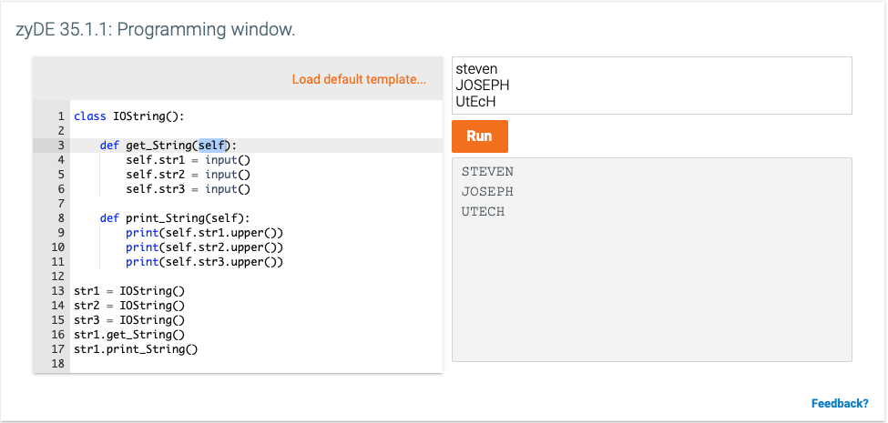



# Problem 3: R Programming Problem

# (20 Points Total)

* **Perform the following problems using R:**
  + Create a vector of courses (e.g., MATH 101) you have taken previously. Make sure you have at least 8 courses. Name the vector myCourses
  + Get the length of the vector myCourses
  + Get the first two courses from myCourses
  + Get the 3rd and 4th courses from myCourses
  + Sort myCourses using a method
  + Sort myCourse in the reverse direction
* *INSERT* *code below* and *INSERT* a screen shot of the program and successfully run output.

myCourses <- c("MATH101", "STAT515", "ENG101", "MGMT100", "ECON681", "LEAD789", "ACOU610", "DATA630")

myCourses

[1] "MATH101" "STAT515" "ENG101" "MGMT100" "ECON681" "LEAD789" "ACOU610" "DATA630"

length(myCourses)

[1] 8

myCourses[c(1,2)]

[1] "MATH101" "STAT515"

myCourses[c(3,4)]

[1] "ENG101" "MGMT100"

sort(myCourses, decreasing = FALSE)

[1] "ACOU610" "DATA630" "ECON681" "ENG101" "LEAD789" "MATH101" "MGMT100" "STAT515"

sort(myCourses, decreasing = TRUE)

[1] "STAT515" "MGMT100" "MATH101" "LEAD789" "ENG101" "ECON681" "DATA630" "ACOU610"



# Problem 4: Principal Component Analysis

# (25 points)

**Provide a description of the following:**

1. What is a component – Provide a description (5 points)
2. Principal Component Analysis – Provide a description.(5 points)
3. **Provide an specific example of Principal Component Analysis(15 points)**
4. Principal components are typically new variables that are constructed as a linear combination of the initial variables. These combinations are done in such a way that the components or new variables are uncorrelated and most of the information within the initial variables are squeezed as much as possible in order to fit within the first components, and then squeezed as much as possible to fit within the second components, etc.
5. Principal Component Analysis or PCA is a tool used for data visualization or data pr-processing before supervised techniques are applied, where PCA produces a low-dimensional representation of a dataset. It finds a sequence of linear combinations of the variables that have maximal variance and are mutually uncorrelated.

Apart from producing derived variables for use in supervised learning problems, PCA also serves as a tool for data visualization.

1. There are ~328m people that are US citizens, however hearing from each individual citizen in order to influence or inform policy is not practical or efficient, so we elect 535 officials that are principal components that are representative of the ~328m people. This take a high dimensional representation to a low-dimensional representation of a dataset. It finds a sequence of linear combinations of variables that have maximum variance, but are uncorrelated

# Problem 5: Multiple vs. Logistic

# (30 points)

# Describe: What is difference between Multiple Regression and Logistic Regression? What circumstances might determine which to use? (10 points)

# Demonstrate: Using any data, and any tool set you’ve learned about, show differences (20 points)

# SUGGESTION: may be solved using RapidMiner, or other toolsets, BOTH TO ANALYZE AND TO VISUALIZE REGRESSION DIFFERENCES.

Step 1: Perform a quick search of the [UCIS public data archive](https://archive.ics.uci.edu/), a well-curated site which you already have seen as part of your introductory RapidMiner training.

Step 2: Pick a dataset you find interesting, input dataset into regression tools you’ve chosen.

Step 3: Run regression, .and use visualizations to demonstrate the conceptual answers you provided for 5.(a).

In order to get to the heart of the question, it’s important to understand that:

-Logistic regression is used when the response variable is qualitative (e.g., yes/no, male/female, success/failure), and is often coded as 0 or 1. Among other things, logistic regression is useful for modelling the probabilities and indicating the likelihood of the response occurring for different values of the predictor variables.

-Linear regression is used when the response variable is quantitative and is useful for modelling the relationship between a numeric outcome or dependent variable (y) and one independent variable (x) .

-Multiple regression on the other hand can be both linear and logistic in nature and is simply taking one dependent variable(y) that may be either dichotomous (logistic) or numeric (linear), but now is using multiple explanatory or independent variables (x) for modeling the relationship between x and y.

-Simple linear regression uses a single independent variable (predictor X) where we can determine the importance of explaining y based on x.

The circumstances in which you would use any one of these is based on the data (i.e. qualitative vs quantitative) and what questions you are asking of the data (i.e. is the analysis univariate or multivariate in nature).

b.

Below is a look at a simple linear regression of UCI – MPG Automotive data where the y is MPG and the x is model year. If a new car in this model year(x) is used, the correlated MPG is expected.

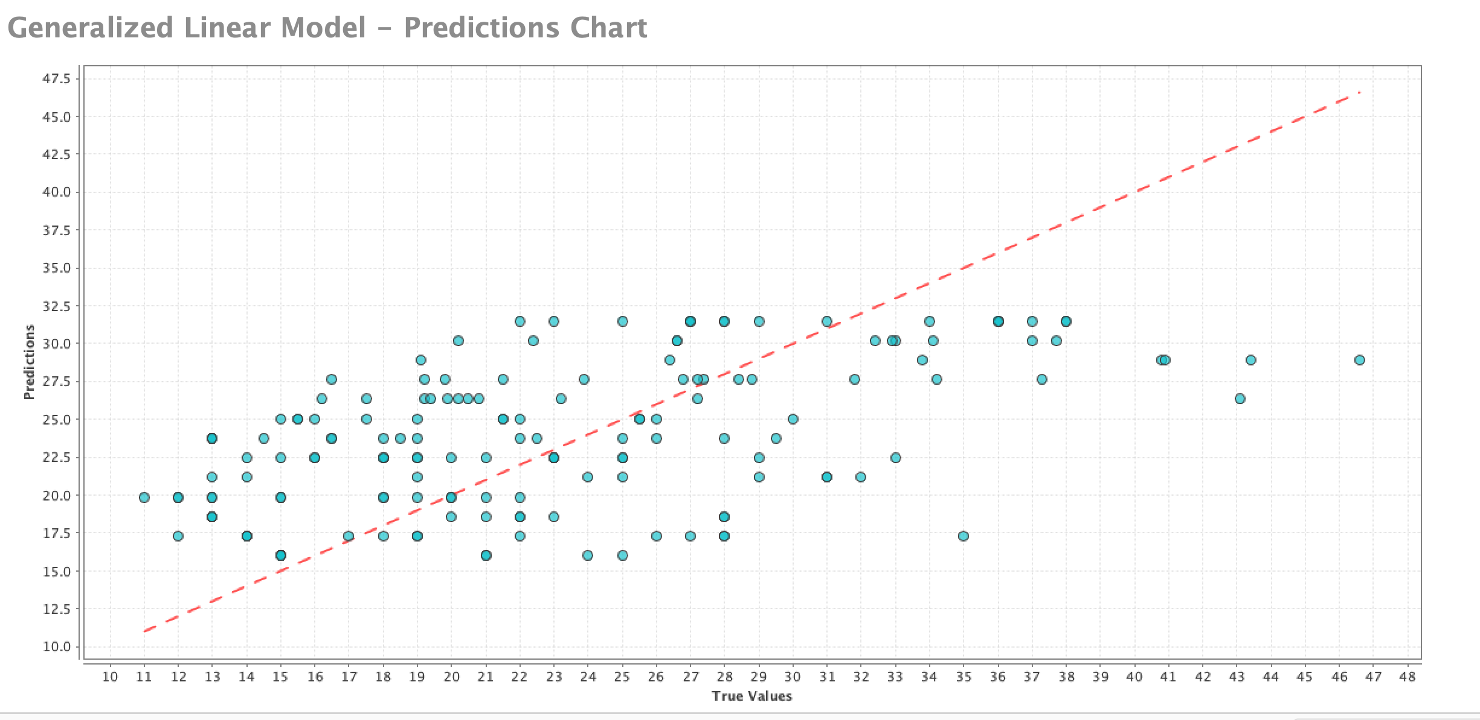

Below is a look at a multiple linear regression of UCI – MPG Automotive data where the y is MPG and the x are acceleration, cylinders, displacement, model year, origin and weight. Multiple regression did the same thing as simple regression except that we can now predict MPG given acceleration, cylinders, displacement, model year, origin and weight.

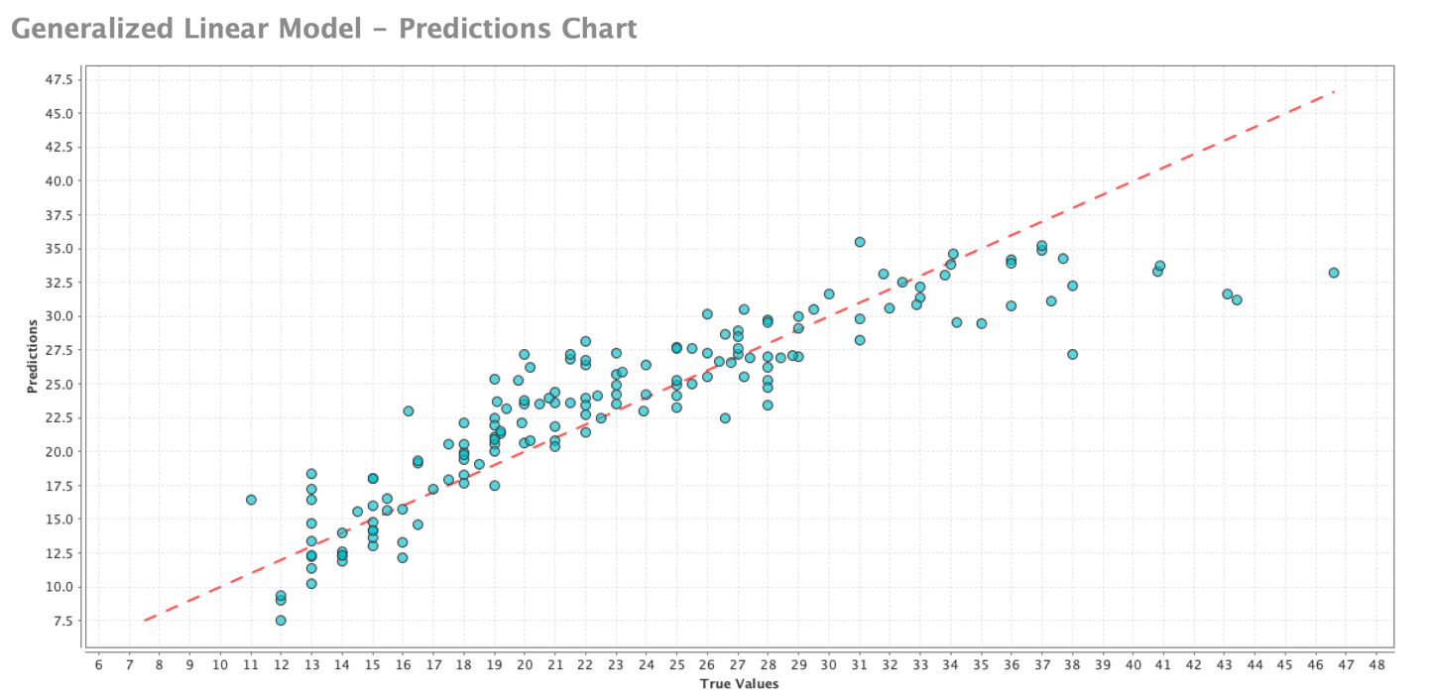

Below is a look at a logistic regression of MPG Automotive data where the y is 4cylinder and not 4cylinder and the x is weight of the car. Notice that the plot looks different; with points plotted on the top and bottom of the graph. The logistic regression doesn’t fit a line, but rather a function that tells you the probability and helps to classify a car that has a 4cylinder engine based on its weight. Logistic regression is also good at testing the effect on the prediction and if it is significant and /or whether or not the variable is helping the overall model.

